**Executive Business plan – Madonn’**

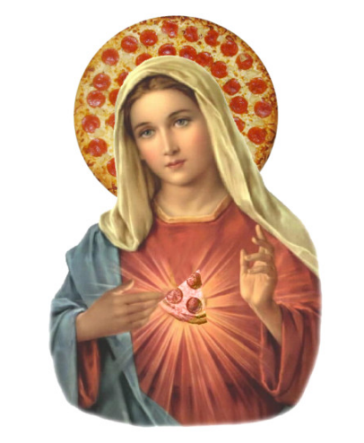

*Prepared by Jurgen Xhafaj*

(Italian restaurant in Stephenville, Texas)

(image credit: https://www.teepublic.com/t-shirt/2173250-virgin-pizza)

1. The only Italian thing about Italian restaurants and pizza places in this town is the fact that their name refers to pizza or is in Italian language. The atmosphere in either place is absolutely nothing even close to the real deal. Italian beverages are lacking, and no place is open for breakfast.

Some places have outdated and non-maintained websites. Others have a very limited website that gives little to no options for online ordering. Social media links are missing in some cases or are not properly displayed. As a matter of fact, one of the “Italian ristorante”-s does not even display its business hours on their website. All of these issues demand that there is a new cool kid in town, who offers a solution to these discrepancies.

**Madonn’**

1. Madonn’! What kind of buffoon does this to Italian culture? We will bring an actual Italian restaurant to educate others on what genuine and authentic Italian cuisine is, in all of its glory. Madonn’ will have a breakfast, lunch, and dinner menu, and it will be open 7am to midnight, so people can have a quick breakfast before class/work, have lunch at lunch break, and even have dinner together with the family. A true Italian restaurant plays Celentano and Ramazotti, instead of the current top five worst songs from the local radio station. As the business moves forward, we plan to add events and party options, and a possible expansion when time comes.

In plain words, the product we are selling is the authentic Italian atmosphere combined with authentic Italian food. However, we will include other products, which are on popular demand, to add revenue to our business. We will also sell authentic Italian beverages, which will require some friends in Brooklyn and Napoli.

1. The income from Madonn’ will come through two components: the online purchases through the website, and payments made inside the fine dining facility that would rightly be called “THE” Italian restaurant. So Italian that it would not need to have “ristorante” on its name to make it feel authentic. The name itself comes from “Mia Donna” (My Lady), which refers to Virgin Mary, but it is also an expression used when one is surprised. That is exactly what we strive to make the customers feel like upon coming to our place, and after they leave.

At the start, the website will allow the purchase of food online, while accepting most of the available cards. Later, Madonn’ gift cards will be a thing and the website will even sell merchandise that has its logo, preferably small Italian souvenirs and t-shirts. Of course, the website will have links to the Facebook page and its “Like” button, as well as a Twitter plug in to see the latest tweets from Madonn’.

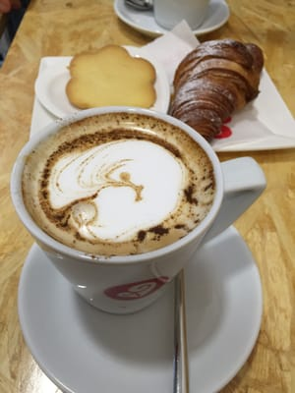

1. Initially, we would expect our customer to be the locals, which includes several categories. The typical college student would be Jack. He always loves some cheap breakfast prior to going to class. Jack would love some bacon and eggs for breakfast, so that will certainly be part of our breakfast menu. Our opening hour is 7am, so people have some time to eat and then go to class, which would start at eight the earliest. Then, there is Tiburcio, a graduate student who has some class and good manners, and would like to have something more Italian, like macchiato, biscotti, and brioche, as shown on the right. (source: <https://s3-media4.fl.yelpcdn.com/bphoto/D7X2Ylz9Hj1FuX3rLn4kSw/l.jpg> ) That would be the second part of our breakfast menu: the Italian breakfast. The lunch will include locally served food and of course, delicious Italian dishes such as Carbonara Pasta, Gnocchi Alla Margarita, Pasta Abruzzi, etc.

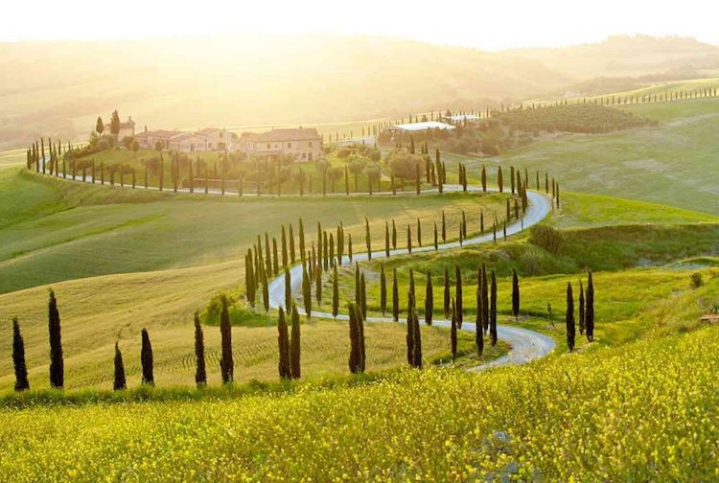While Tiburcio will order such food once in a while for lunch/dinner, Mr. and Mrs. Jones, the local “aristocrats” would come to have a full meal more often, and sometimes they will have the kids with them. A good selection of wines and a kids’ menu would be mandatory to attract this couple to our place. Mrs. Jones has a taste for art, so the restaurant will have a couple of paintings, as well as artistic photos of the Italian village landscape, as Val D’Orcia, on the right. (source: <http://www.weddinginvaldorcia.com/public/images/medium/le-5-esperienze-che-non-potete-perdere-in-val-dorcia-1.jpg>) They will be the kind of customer who can afford a good meal but have a strict schedule, so they will often order online. A good looking and user-friendly website would certainly help to keep them coming back.

The Psychology Department of TSU is always looking for new places to explore food that is not of Mc Donald’s quality, and once they check the local recommended places on Facebook, they will give Madonn’ a try. That is a lot of people coming in, which will require additional staff to keep them busy dining and happy at the same time. After they get that internal “Madonn’!” feeling, they will ask for more, and possibly catering services. That would be one of the first major hurdles of our business, since it does require a lot of connections to find the right person to coordinate the workers, which for the time being will be a friend of mine who is local and also loves tasty food, in addition to being in constant contact with hundreds of people every day. Part of the investment will go to advertising the business on Facebook and YouTube, and part of it will go to advertising on campus.

As a way to advertise on students, we might invite several professors to have a meal on us and ask them to mention our place in their classes. Another part that would help is online testimonies, which need to be carefully edited to be short and precise, so people actually watch it. This would include different types of customers, because we do not want our place to be exclusively for higher class citizens. A student with their parents, a couple and perhaps an overly happy grandpa will cut it. 3 videos on the Testimonials section is not too many, but not too little either. Besides the aforementioned characters, there will be the college students who can afford something a bit pricey but of a much higher quality that Schlotzky’s subs or Little Ceasar’s mass production pizza.

1. The food at our place will be authentic Italian food, not cheap knock-off food that’s been adjusted to fit the desires of a Mc Donald’s customer. Truth told, the prices will be higher, but the increase in quality will be so much worth the extra 2-3 dollars per pasta plate. The wine license will be costly, but it will quickly turn a lot of profit. Some types of wine would have to be imported from Napoli or Sicilia, but it will help spread the word on the city about the uniqueness of our restaurant.

The business hours starting at 7am will also be a big plus when compared to wannabe Italian restaurants. Last, but not least, our website will be useful, and regularly maintained. Below are some observations from websites that belong to current Italian / pizza places in Stephenville. It contains what they’re missing, as well as what they do have, so we make sure we include the good stuff as well on our website.

What others are missing and what useful features they do have

Pastafina (visited once) http://www.pastafinas.com/menu.htmlt

* website uses the same picture in 3 categories of home page
* no options for online purchase (just call in available) & pick up / delivery
* menu category only displays dinner menu, and you have to download the lunch and catering menus
* no breakfast
* No open times published on website
* No Facebook page link posted on website
* A TripAdvisor review says “It was oddly quiet so we could tune in to other conversations if we’d wanted.”, so the music choice could be better, and Adriano Celentano, Nek, Andrea Bocelli, and Eros Ramazzotti would complete the satisfactory experience.
* Not certified as a Secure Website

+Homepage has Links to Lunch and Dinner menu, locations with photos and numbers

+Permanent display of locations, numbers, catering being available, and cards accepted

+Popular beverages, but no classic Italian ones

The PIZZA Place (not visited) http://www.thepizzaplaces.com/home.html

* 11am-9pm, NOT for late dinner dates & co
* Gallery only displays a simple collection of 6 photos of food with no descriptions or artistic effects; BUT you can click to enlarge them
* Menu link just opens a menu PDF, not an actual page; last updated on 2015
* “Order Now” button leads to a “Not Found” page (not working for online ordering)
* Android App Store link leads to “Not Found” page
* Apple App Store link stuck on “Connecting to the iTunes Store.”
* Facebook page link only displays half of it
* Seems like a chain of mass production (fast food mentality), instead of a place that cares about your dining experience (classy restaurant)
* Photo Gallery on homepage displays a picture 3 times and another two times, not aesthetically pleasing
* Not certified as a Secure Website

+Address & phone nr. displayed on top of page at all times

+Slideshow with 4 pages on homepage (though the 4th one does not display any image, just text)

+Contact Us Form works (link to it on homepage works too)

+About Us page is decent (though no pictures on it)

+Has Twitter Feed plug in

1. The first person to be hired would be the web developer and designer. They would have to create and maintain the website for our restaurant. Hiring the right person here would help a lot, and to do that I will use my connections at Tarleton and especially the current and recently graduated Data Miners to give suggestions in finding the perfect candidate. To help with the e-commerce part, we’d hire a part time programmer. This position is crucial too, since we would want our customers to be able to pay with multiple types of cards, and if it is a big order, perhaps using their bank account details too, and even store them on their SAFE accounts.

Another person to hire will be Tu Nguyen, a web security expert who would make sure that our website is safe and that everybody’s information is safe as well. I know Tu personally, and I would go to sleep without having to worry that a Facebook kind of scandal would happen to my customers’ precious data and information. Soon enough, once things are on a straight line, we would implement a mobile app for Madonn’, which would require us to hire a part time programmer to convert the website into a mobile app (for Android and iOS) and update it once in 3 months. This mobile app would be especially helpful if we do manage to get an expansion on TSU campus. Student would absolutely love to order their breakfast early and eat some quality food instead of Sodexo’s Great Value sausages which were cooked the day before and stayed on the fridge overnight. Finally, as more customers come in, we would need a part time data analyst who would give us insights on tweets about local food places and also consider our logs and data to tell us when we need more staff, which food is bringing more revenue, and several other optimization tasks that would be necessary for a business that aims to get a 100% customer satisfaction.